Shelby Bicycle Days’
LINDY FLYER COMMUNITY BIKE TOUR
ELEVENTH ANNUAL

Named for one of the Shelby Cycle Company's most popular models, this free tour offers four loop rides through the historical community and surrounding farmlands.
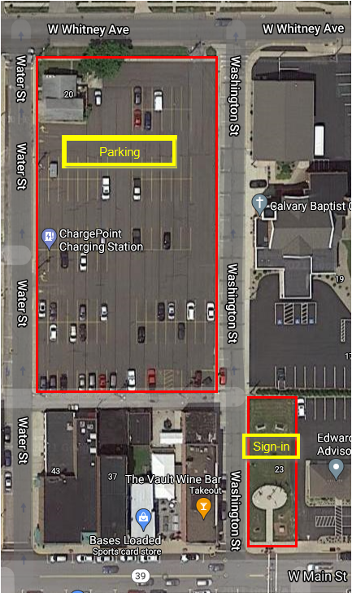
Routes of 12/18/27/28 flat to hilly miles are offered – ride any or all loops for your choice of terrain and mileage. First riders out at 8:30 a.m. last riders out by 1:30p.m. All loops start and stop at sign-in location.Posted routes may vary slightly due to late notification of road closures.
No early sign-in required, sign-in day of event. Sign-in at the corner of W. Main St. & Washington St. at the flag park. Use 23 West Main St, Shelby for directions. See image below.
Parking is available between W. Main St. and W. Whitney Ave. Use Water St off Main St. or use W. Whitney Ave to access the parking lot. Washington St. will be closed for rider safety. No parking is allowed on Main St. due to afternoon parade. See image below.
Free snacks and drinks provided. No entry fee. Donations requested. No T-shirt sales available for event. Public restrooms available in the Black Fork Commons park.
Food trucks will be available along with several downtown restaurants and nearby fast food restaurants.
Release forms will be available at sign-in or the release form can be found below if you like to print and sign form prior to arrival.
A large collection of Shelby Cycles will be on display in downtown storefronts.
For additional information contact: Kevin John; 21 Cold Draw Ct.; Shelby 567-303-9007, kpj@neo.rr.com.

Lindy Flyer Ride – Release and Waiver of Liability, Assumption of Risk, and Indemnity and Parental Consent Agreement (“Agreement’)
IN CONSIDERATION ofbeing permitted to participate in any way in the LINDY FLYER RIDE sponsored Bicycling Activity (“Activity”) I, for myself, my personal representatives, assigns, heirs, and next of kin:
- ACKNOWLEDGE, agree, and represent that I understand the nature of Bicycling Activities and that I am qualified, in good health, and in proper physical condition to participate in such Activity. I further acknowledge that the Activity will be conducted over public roads and facilities open to the public during the Activity and upon which the hazards of traveling are to be expected. I further agree and warrant that if, at any time, I believe conditions to be unsafe, I will immediately discontinue further participation in the Activity.
- FULLY UNDERSTAND that (a) BICYCLING ACTIVITIES INVOVE RISKS AND DANGERS OF SERIOUS BODILY INJURY, INCLUDING PERMANENT DISABILITY, PARALYSIS AND DEATH (“RISKS”), (b) these Risks and dangers may be caused by my own actions, or inactions, the actions or inactions of others participating in the Activity, the condition in which the Activity takes place, or THE NEGLIGENCES OF THE “RELEASEES” NAMAED BELOW; (c) there may be OTHER RISKS AND SOCIAL ECONOMIC LOSSES either not known to me or not readily foreseeable at this time and I FULLY ACCEPT AND ASSUME ALL SUCH RISKS AND ALL RESPONSIBILITY FOR LOSSES, COSTS, AND DAMAGES I incur as a result of my participation or that of the minor in the Activity.
- HEREBY RELEASE, DISCHARGE, AND COVENANT NOT TO SUE Lindy Flyer Ride, Shelby Bicycle Days, the Community Improvement Corporation of Shelby, their administrators, directors, agents, officers, members, volunteers, and employees, other participants, and sponsors, advertisers, and, if applicable, owners and lessors of premises on which the Activity takes place, (each considered one of the “RELEASEES” herein) FROM ALL LIABILITY, CLAIMS, DEMANDS, LOSSES, OR DAMAGES ON MY ACCOUNT CAUSED OR ALLEGED TO BE CAUSED IN WHOLE OR IN PART BY THE NEGLIGENCE OF THE “RELEASEES” OR OTHERWISE, INCLUDING NEGLIGENT RESCUE OPERATIONS AND I FURTHER AGREE that if, despite the RELEASE AND WAIVER OF LIABILITY, ASSUMPTION OF RISK, AND INDEMNITY AGREEMENT I, or anyone of on my behalf, makes a claim against any of the Releasees, I WILL INDEMNIFY, SAVE, AND HOLD HARMLESS EACH OF THE RELEASEEES from any litigation expenses, attorney fees, loss, liability, damage, or cost which any may incur as the result of such claim.
I HAVE READ THIS AGREEMENT, FULLY UNDERSTAND ITS TERMS, UNDERSTAND THAT I HAVE GIVEN UP SUBSTANTIAL RIGHTS BY SIGNING IT, AND HAVE SIGNED IT FREELY AND WITHOUT ANY INDUCEMENT OR ASSURANCE OF ANY NATURE AND INTEND IT TO BE A COMPLETE AND UNCONDITIONAL RELEASE OF ALL LIABILITY TO THE GREATEST EXTENT ALLOWED BY LAW AND AGREE THAT IF ANY PORTION OF THIS AGREEMENT IS HELD TO BE INVALID THE BALANCE, NOTWITHSTANDING, SHALL CONTINUE IN FULL FORCE AND EFFECT.

I I HAVE READ THIS RELEASE DATE: PHONE:

PRINTED NAME OF PARTICIPANT:

PARTICIPANT’S SIGNATURE (only if age 18 or over):

ADDRESS:
(Street) (City) (State) (ZIP

EMAIL ADDRESS:

EMERGENCY CONTACT: PHONE:

MINOR RELEASE
AND I, the minor’s parent and/or legal guardian, understand the nature of bicycling activities and the minor’s experience and capabilities and believe the minor to be qualified, in good health, and in proper physical condition to participate in such activity. I hereby release, discharge, covenant not to sue, and agree to indemnify and save and hold harmless each of the releasees from all liability, claims, demands, losses, or damages on the minor’s account caused or alleged to be caused in whole or in part by the negligence of the “releasees” or otherwise, including negligent rescue operations and further agree that if, despite this release, I the minor, or anyone on the minor’s behalf makes a claim against any of the releasees named above, I will indemnify, save, and hold harmless each of the releasees from any litigation expenses, attorney fees, loss liability, damage, or cost any may incur as the result of any such claim.

I HAVE READ THIS RELEASE DATE: PHONE:

PRINTED NAME OF PARENT/GUARDIAN:

PARENT/GUARDIAN SIGNATURE (only if age 18 or over):

ADDRESS:
(Street) (City) (State) (ZIP

