Shelby Bicycle Days
Lindy Flyer Community Bike Tour
18.4 Mile Tour – Yellow Loop 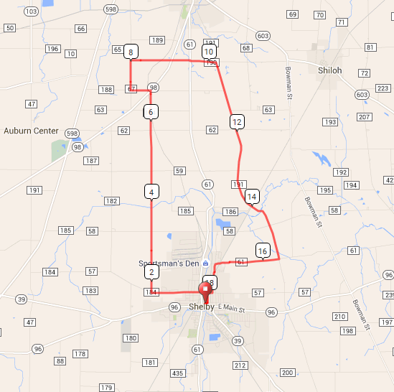
Mile Direction
0.0 R onto W Whitney Ave
0.1 L onto Mohican St
0.3 L onto E Smiley Ave
1.7 R onto Kuhn Rd
6.8 R onto OH-98 N
6.8 L onto Henry Rd
7.3 R onto Fenner Rd
8.0 R onto Opdyke Rd
9.5 R onto OH-61 S
9.5 L onto Opdyke Rd
10.2 R onto Ply. Springmill Rd
14.7 Continue onto Ply. Springmill Rd
15.6 R onto Shelby-Ganges Rd
17.1 Continue onto E State St
17.2 L onto Broadway St
17.9 R onto E Smiley Ave
18.0 L onto Mohican St
18.3 R onto E Whitney Ave
18.4 L onto Washington St
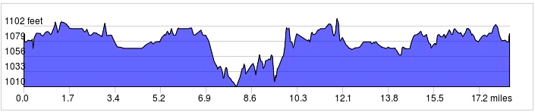
Follow Yellow Markings: -->>
LF
Sign in and out for each loop
No SAG Vehicles
Started In: Shelby, OH
Ends in: Shelby, OH
Distance: 18.4 mi
Elevation: +425/-421 ft

