Shelby Bicycle Days
Lindy Flyer Community Bike Tour
27.7 Mile Tour – White Loop 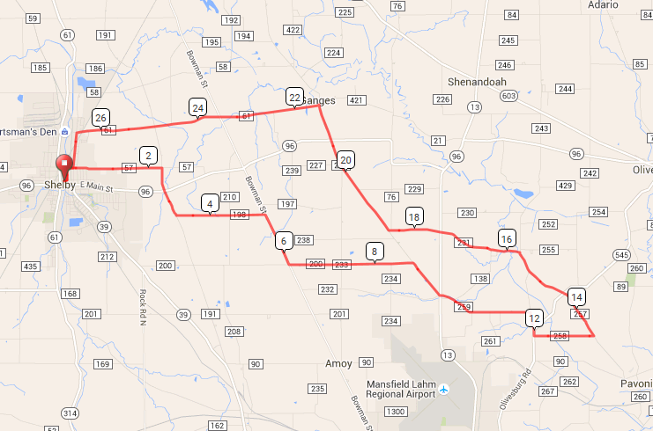
Mile Direction
0.0 R onto W Whitney Ave
0.1 L onto Mohican St
0.3 R onto E Smiley Ave
2.3 R onto Plymouth Springmill Rd
3.3 L onto Holtz Rd
5.1 R onto Bowman St
6.3 L onto Taylortown Rd
8.8 R onto Ganges-Five Points Rd
9.6 Continue onto 5 Points East Rd
11.6 R onto Franklin Church Rd
12.0 R onto OH-545 S
12.1 L onto Pittinger Rd
13.4 L onto Robinson Rd
15.3 Continue onto Franklin Church Rd
15.7 L onto Chesrown Rd
16.3 R onto Brubaker Creek Rd
16.3 L onto Chesrown Rd E
18.5 R onto Ganges-Five Points Rd
21.5 L onto Shelby-Ganges Rd
26.4 Continue onto E State St
26.5 L onto Broadway St
27.2 R onto E Smiley Ave
27.4 L onto Mohican St
27.6 R onto E Whitney Ave
27.7 L onto Washington St
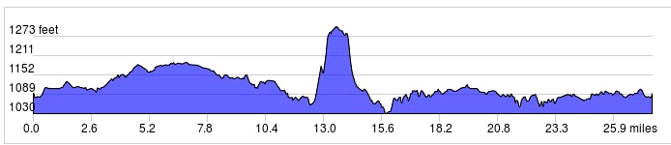

Started In: Shelby, OH
Ends in: Shelby, OH
Distance: 27.7 mi
Elevation: +747/-746 ft
Follow White Markings: -->>
LF
Sign in and out for each loop
No SAG Vehicles

