Shelby Bicycle Days
Lindy Flyer Community Bike Tour
26.5 Mile Tour – Orange Loop 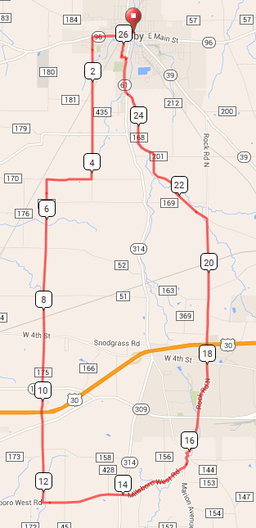
Mile Direction
0.0 L onto W Whitney Ave
0.2 L onto Church St
0.3 R onto W Main St
1.0 L onto Vernon Rd
1.4 Continue onto Hummell Rd
4.1 R onto Settlement East Rd
5.1 L onto N Horning Rd
12.2 L onto Millsboro West Rd
15.9 L onto Lexington Ontario Rd
15.9 R onto Rock Rd S
21.2 L onto Stiving Rd
24.9 R onto OH-61 N/S Gamble St
25.6 L onto Grace Ave
25.7 R onto Walnut St
26.2 R onto W Main St
26.3 L onto Church St
26.4 R onto W Whitney Ave
26.5 R onto Washington St
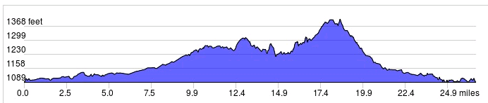
Started In: Shelby, OH
Ends in: Shelby, OH
Distance: 26.5 mi
Elevation: +713/-713 ft
Follow Orange Markings: -->>
LF
Sign in and out for each loop
No SAG Vehicles

