Shelby Bicycle Days
Lindy Flyer Community Bike Tour
28.5 Mile Tour – Blue Loop-2017 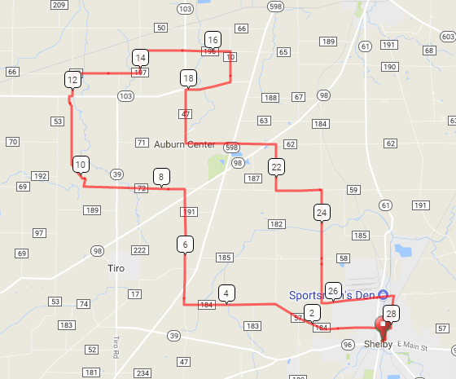
Mile Direction
- R onto W Whitney Ave
  - L onto Mohican St
0.4 L onto E Smiley Ave
3.9 Continue onto Miller Rd
4.9 R onto Baker Rd/Hanna Rd
7.5 L onto Sawyer Rd
9.0 Continue onto Waynesburg-Tiro Rd
11.8 R onto OH-103 E
11.9 L onto N Auburn Rd
12.4 R onto Young Rd
13.9 L onto Serringer Rd
14.4 R onto Kenestrick Rd
16.4 R onto Lauden Rd
17.1 R onto Waynesburg Rd
18.1 L onto Baker 47 Rd
19.2 L onto Auburn Center Rd
21.0 Slight right onto Dinninger Rd
21.2 R onto Champion Rd
22.3 L onto Hazel Brush Rd
23.3 Right onto Kuhn Rd
25.8 L onto W State St/State Street Rd
27.4 R onto Broadway St
28.1 R onto E Smiley Ave
28.2 L onto Mohican St
28.5 R onto E Whitney Ave
28.5 L onto Washington St

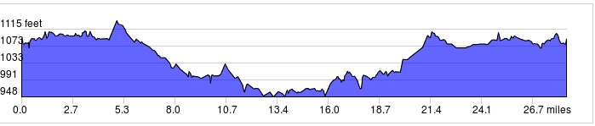
Started In: Shelby, OH
Ends in: Shelby, OH
Distance: 28.5 mi
Elevation: +513/-514 ft
Follow Blue Markings:-->>
LF
Sign in and out for each loop
No SAG Vehicles

